Set up Prometheus and Grafana

Overview

This guide provides a beginner-friendly, step-by-step process to install, configure, and integrate Prometheus and Grafana on an Ubuntu system for system monitoring and visualization.
Prometheus will be set up as a metrics collection and storage system, while Grafana will be used to visualize these metrics in interactive dashboards.
Additionally, Node Exporter is installed to enable Prometheus to collect hardware and OS-level metrics such as CPU, memory, and disk usage. By the end of this guide, you will have a complete monitoring stack running locally, accessible via web interfaces for both Prometheus and Grafana.

Prerequisites
- Ubuntu
- Basic knowledge of Linux commands

Step 1: Update Ubuntu Packages

- Open Ubuntu in your device.

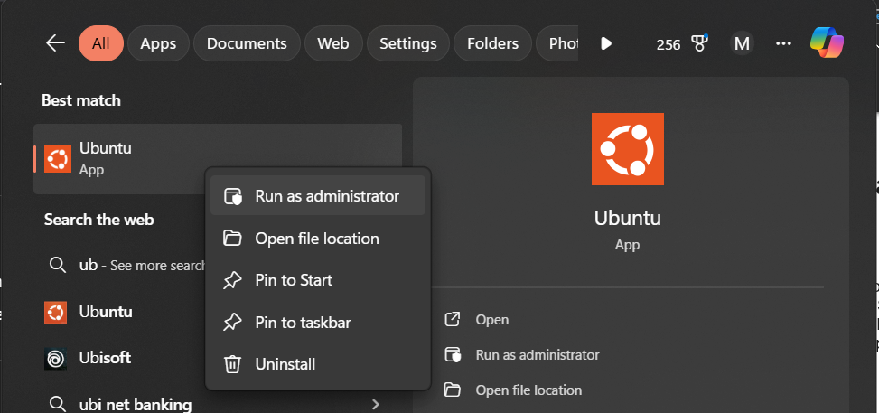

- Before we install anything, we update your system.

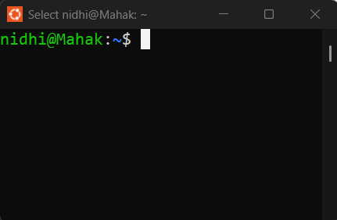
- Run the command:
  - sudo apt update && sudo apt upgrade -y

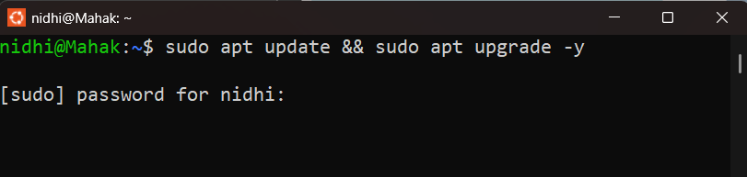

(Enter your ubuntu password)

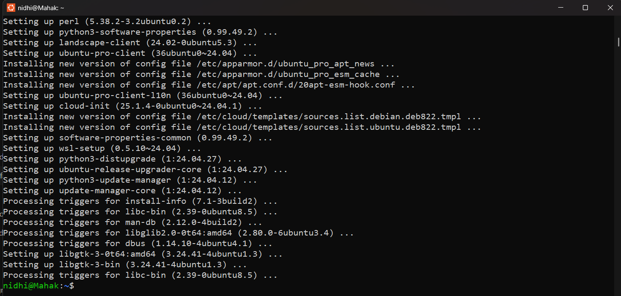

Step 2: Create a New User for Prometheus

- We’ll run Prometheus as a safe, separate user:
  - sudo useradd --no-create-home --shell /bin/false prometheus

(Creates a new user named prometheus.)
- Create required folders for Prometheus:
  - sudo mkdir /etc/prometheus
  - sudo mkdir /var/lib/prometheus
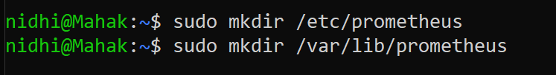

(Creates two folders:
/etc/prometheus → for config files
/var/lib/prometheus → for time series data)

- Set the correct permissions:
  - sudo chown prometheus:prometheus /etc/prometheus /var/lib/prometheus

(Changes the ownership of both directories to the prometheus user and group.)

Step 3: Download Prometheus

- First, go to the Prometheus download page in browser:
  - https://prometheus.io/download/

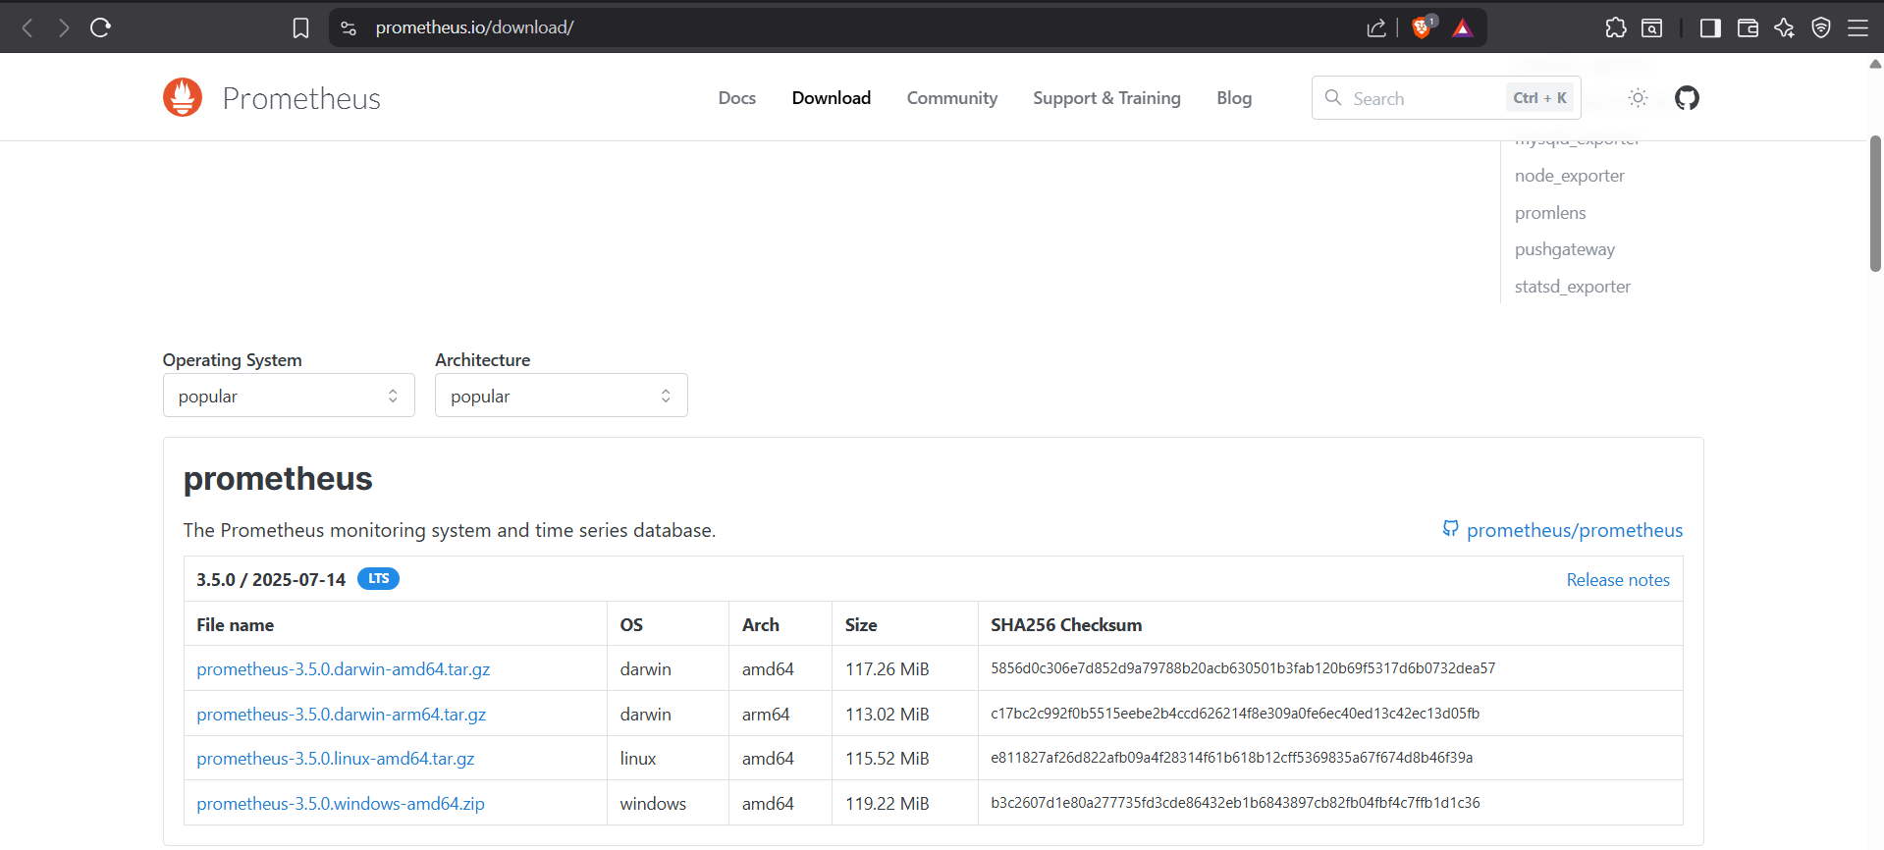

- Scroll down to Prometheus for Linux (amd64).
- Copy the link to .tar.gz file. For example:

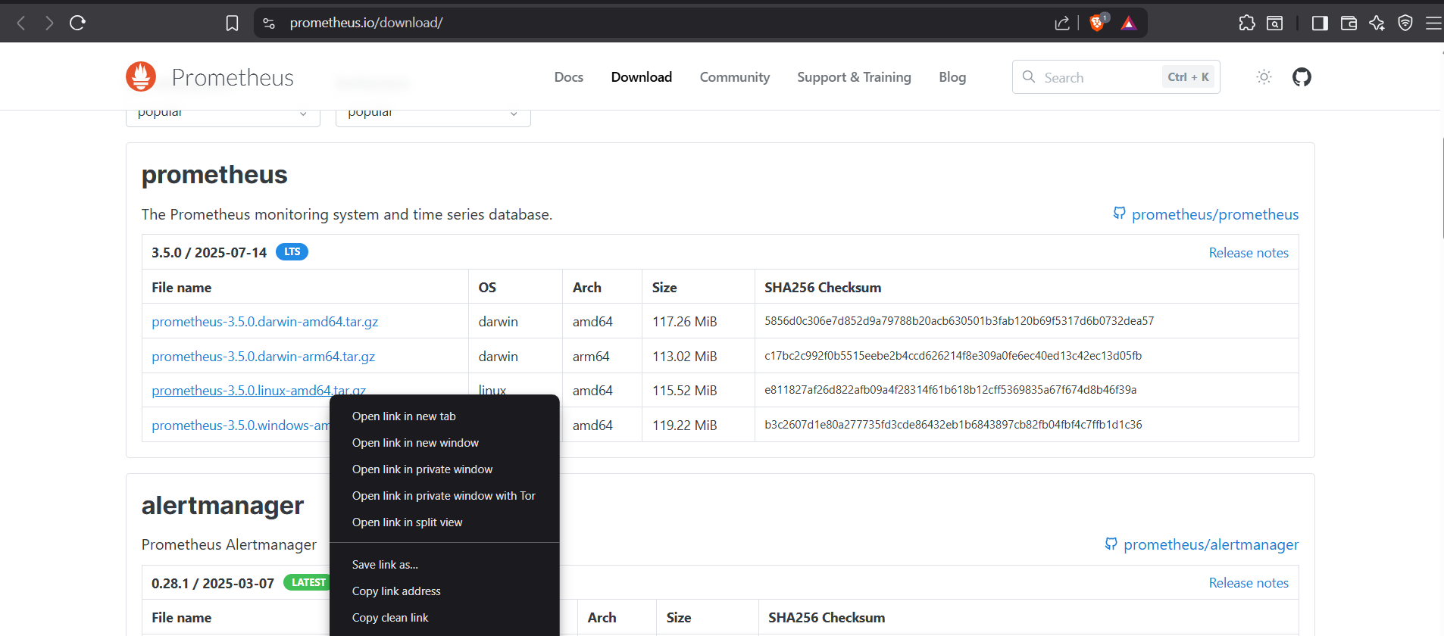

- Back to Terminal, download it:
cd /opt
sudo wget https://github.com/prometheus/prometheus/releases/download/v3.5.0/prometheus-3.5.0.linux-amd64.tar.gz

(Enter your password)

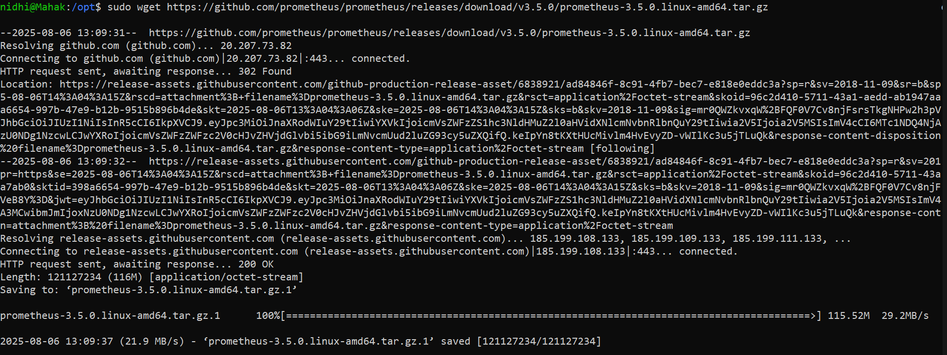

- Extract the downloaded file:
  - sudo tar -xvf prometheus-3.5.0.linux-amd64.tar.gz

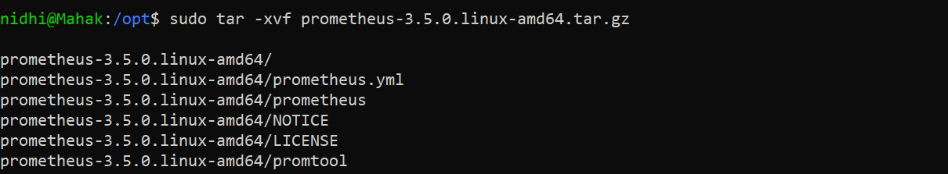

- You should now see a proper directory:
  - ls /opt/prometheus-3.5.0.linux-amd64

- Move the binaries:
  - sudo mv /opt/prometheus-3.5.0.linux-amd64/prometheus /usr/local/bin/
  - sudo mv /opt/prometheus-3.5.0.linux-amd64/promtool /usr/local/bin/

- Create Prometheus config directory and move config file:
  - sudo mkdir -p /etc/prometheus
  - sudo mv /opt/prometheus-3.5.0.linux-amd64/prometheus.yml /etc/prometheus/

Verify:
which prometheus
which promtool
ls /etc/prometheus

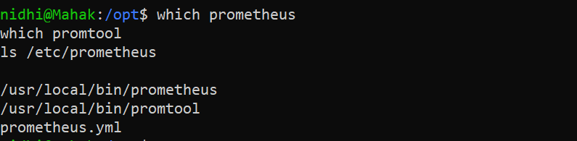

Step 4: Create Prometheus Service

- This makes Prometheus start automatically.
  - sudo nano /etc/systemd/system/prometheus.service

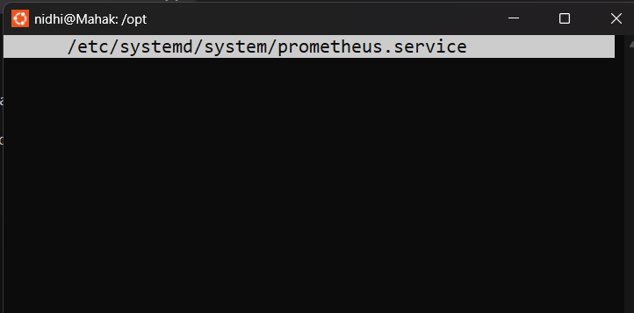

- Inside add the following code:

[Unit]
Description=Prometheus
Wants=network-online.target
After=network-online.target

[Service]
User=prometheus
Group=prometheus
Type=simple
ExecStart=/usr/local/bin/prometheus \
--config.file=/etc/prometheus/prometheus.yml \
--storage.tsdb.path=/var/lib/prometheus

[Install]
WantedBy=multi-user.target

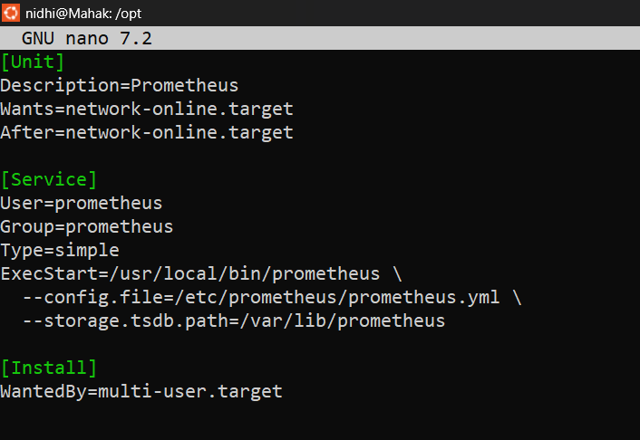

Step 5: Start Prometheus

- To start Prometheus run the following command:

sudo systemctl daemon-reload
sudo systemctl enable prometheus
sudo systemctl start prometheus

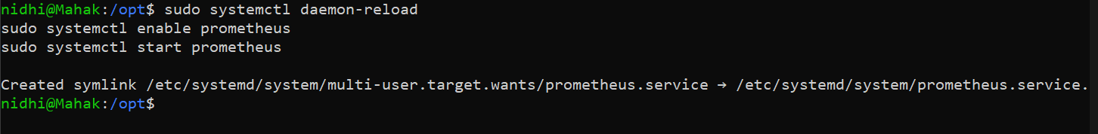

- Check it’s running:
  - sudo systemctl status prometheus

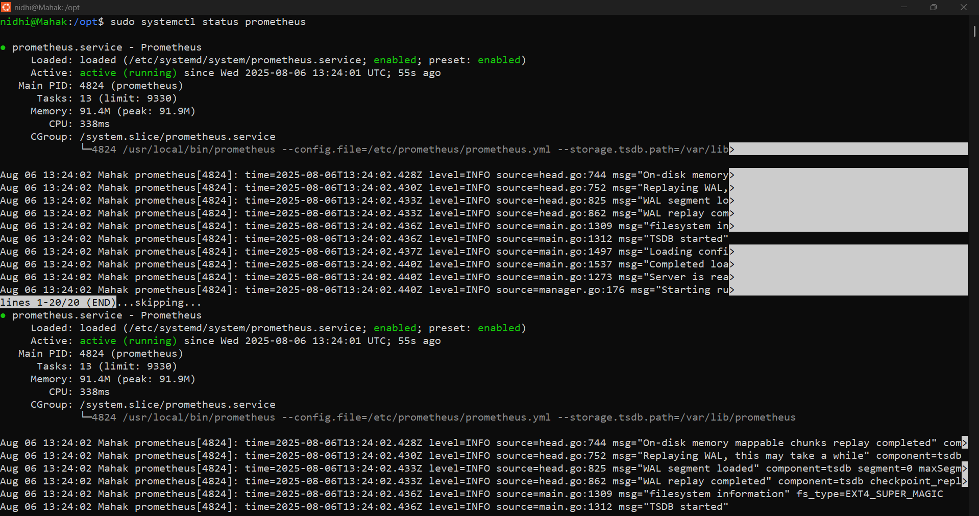

- Visit Prometheus in browser:
http://localhost:9090

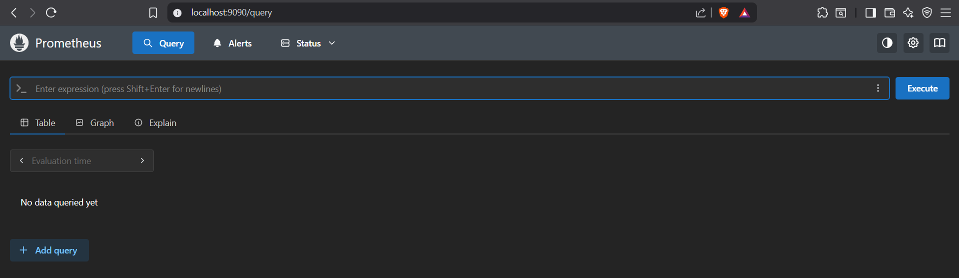

Step 6: Install Node Exporter

This gives system stats like CPU, memory, etc.

- Download Node Exporter:
cd /opt
sudo wget https://github.com/prometheus/node_exporter/releases/download/v1.8.1/node_exporter-1.8.1.linux-amd64.tar.gz

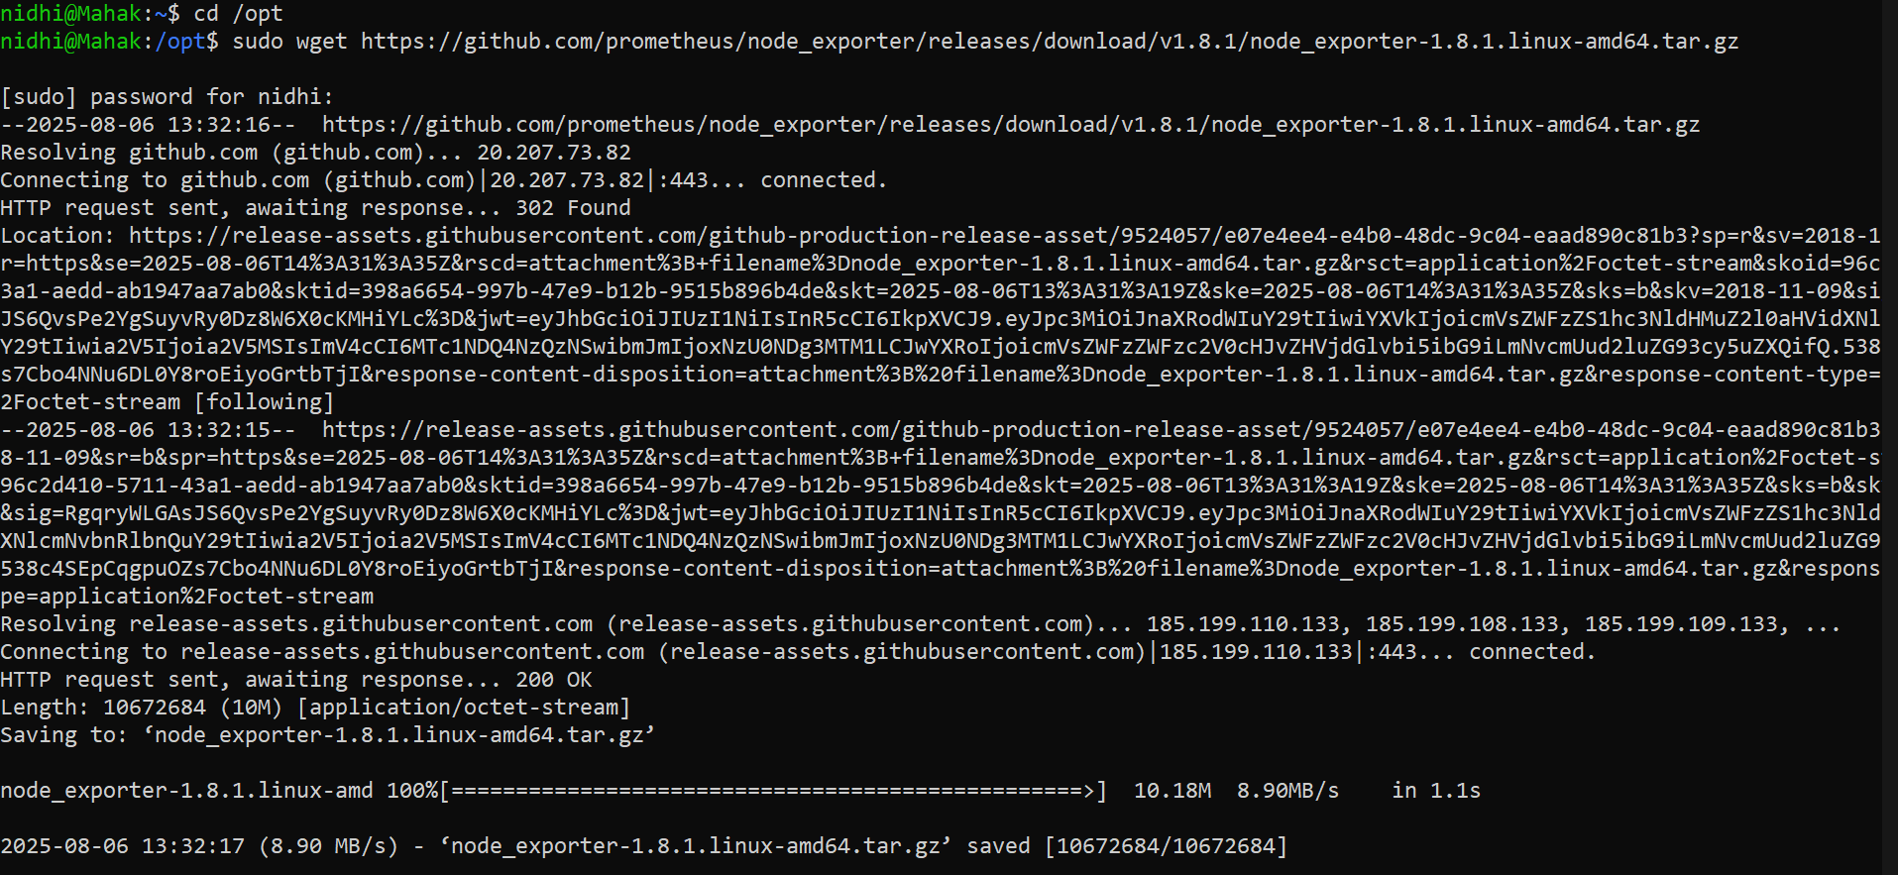

- Extract and move:
sudo tar -xvf node_exporter-1.8.1.linux-amd64.tar.gz
cd node_exporter-1.8.1.linux-amd64
sudo mv node_exporter /usr/local/bin/

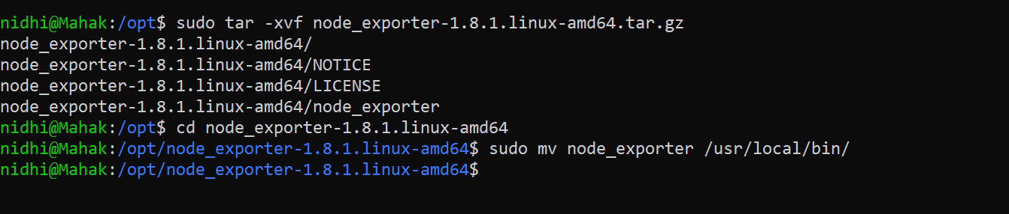

- Create user:
sudo useradd --no-create-home --shell /bin/false node_exporter
sudo chown node_exporter:node_exporter /usr/local/bin/node_exporter

- Create service:
sudo nano /etc/systemd/system/node_exporter.service

- Enter the following code inside:

[Unit]
Description=Node Exporter
After=network.target

[Service]
User=node_exporter
Group=node_exporter
Type=simple
ExecStart=/usr/local/bin/node_exporter

[Install]
WantedBy=multi-user.target

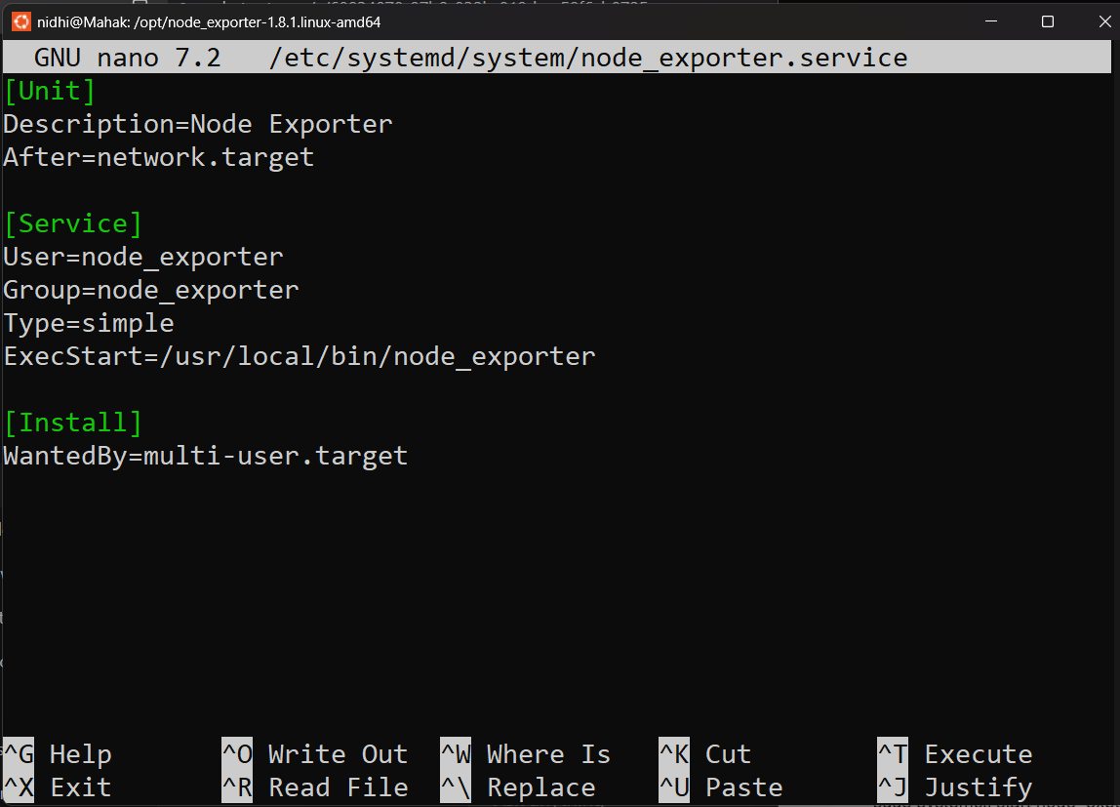

- Start Node Exporter:
sudo systemctl daemon-reload
sudo systemctl enable node_exporter
sudo systemctl start node_exporter

Output:

Check:
http://localhost:9100/metrics

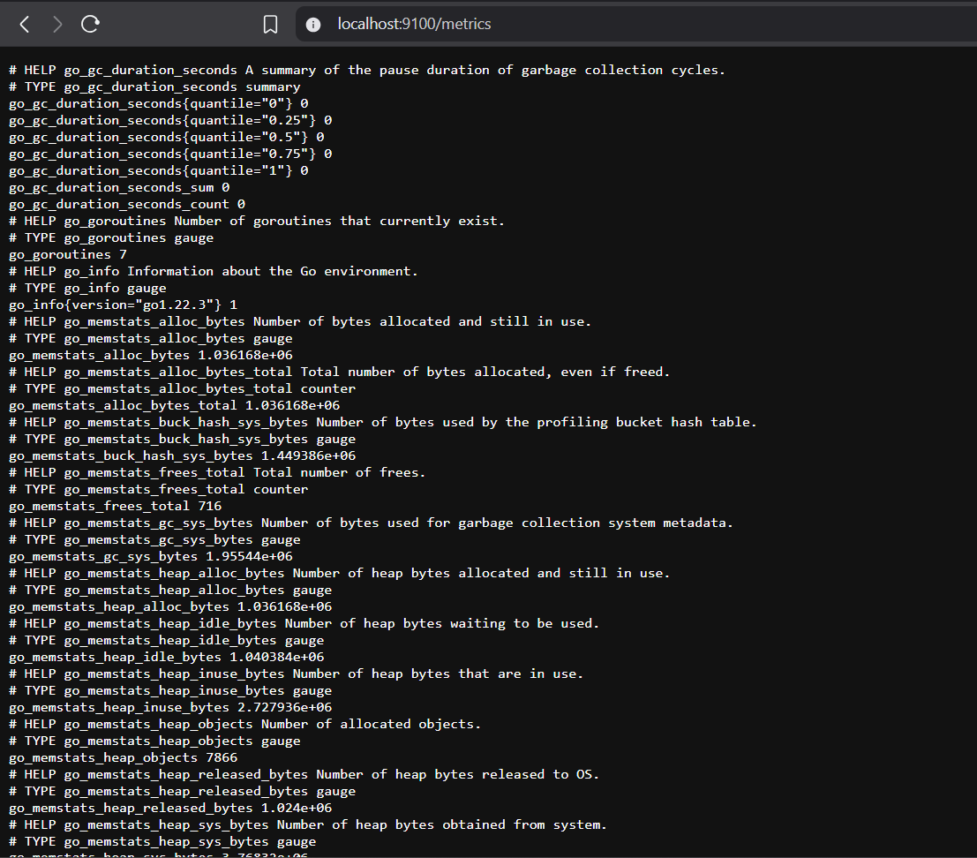

Step 7: Configure Prometheus to scrape Node Exporter

- Open Prometheus config:
  - sudo nano /etc/prometheus/prometheus.yml

- Add this block at the end in Prometheus.yml:

- job_name: 'node_exporter'
static_configs:
- targets: ['localhost:9100']

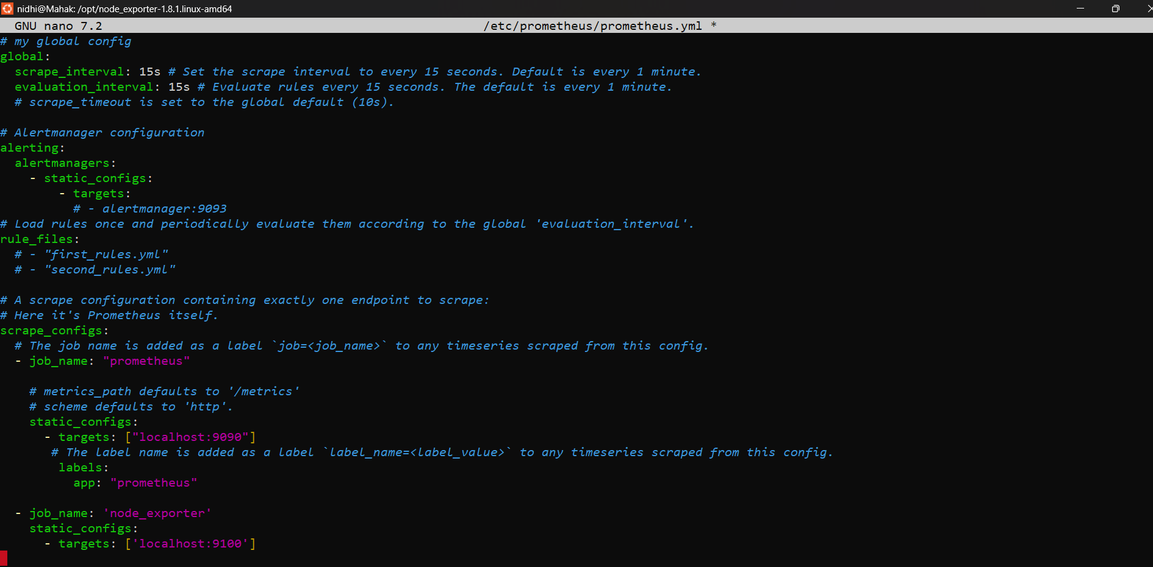

- Now restart Prometheus:
  - sudo systemctl restart Prometheus

Go to:
http://localhost:9090/targets

You should see node_exporter as UP.

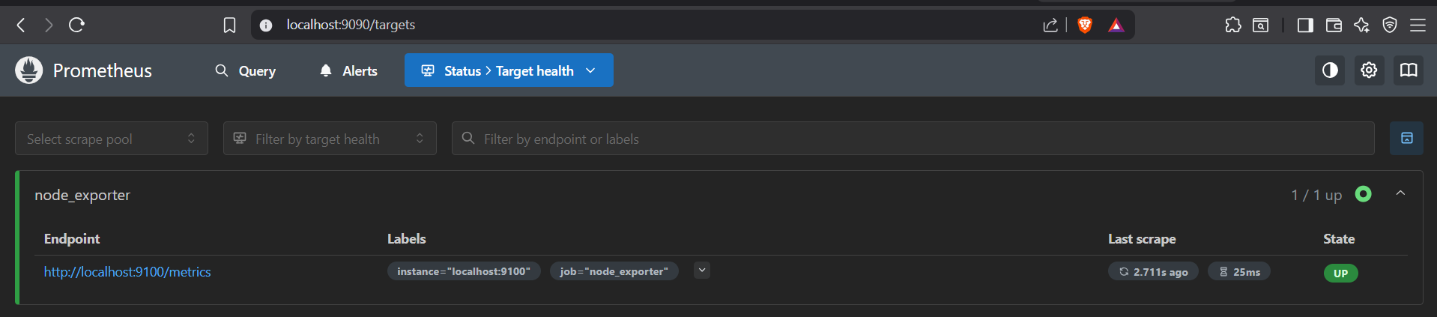

Step 8: Install Grafana

- Open your terminal and run:
  - sudo apt install -y software-properties-common wget

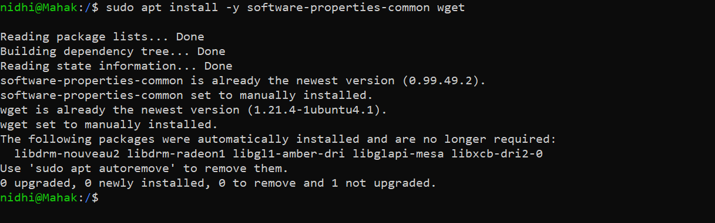

- Add Grafana’s GPG key:
  - sudo wget -q -O - https://packages.grafana.com/gpg.key | sudo gpg --dearmor -o /etc/apt/trusted.gpg.d/grafana.gpg

- Add the Grafana APT repo:
  - echo "deb [signed-by=/etc/apt/trusted.gpg.d/grafana.gpg] https://packages.grafana.com/oss/deb stable main" | sudo tee /etc/apt/sources.list.d/grafana.list

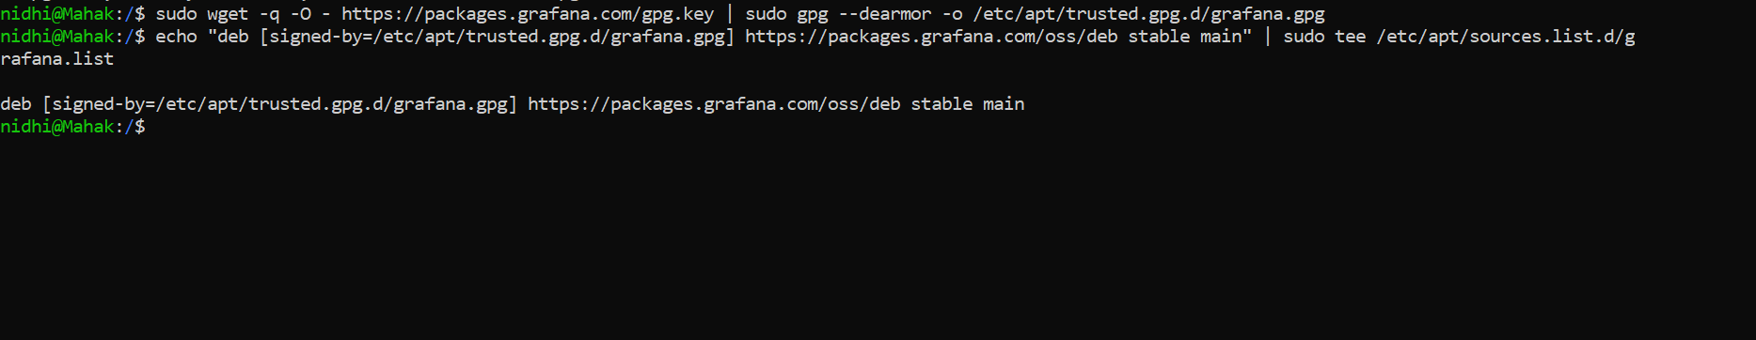

- Update packages:
  - sudo apt update

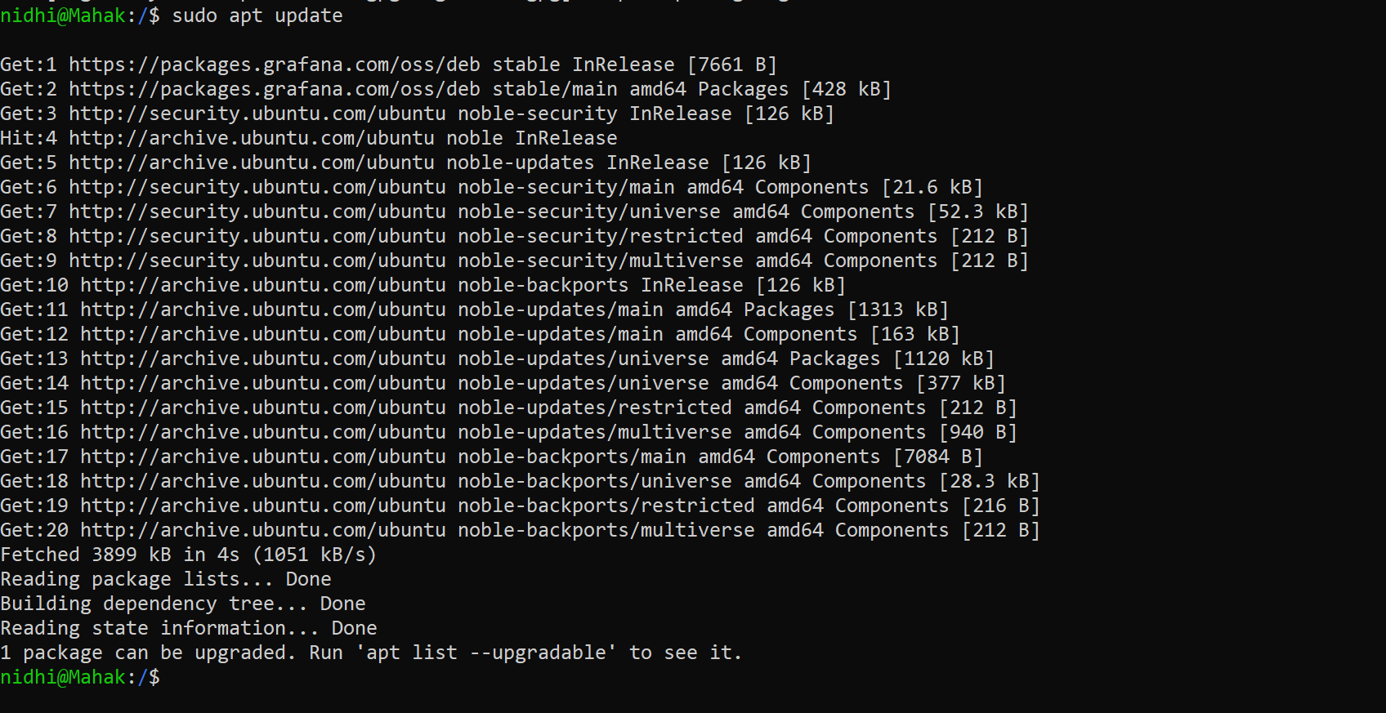

- Install Grafana:
  - sudo apt install grafana -y

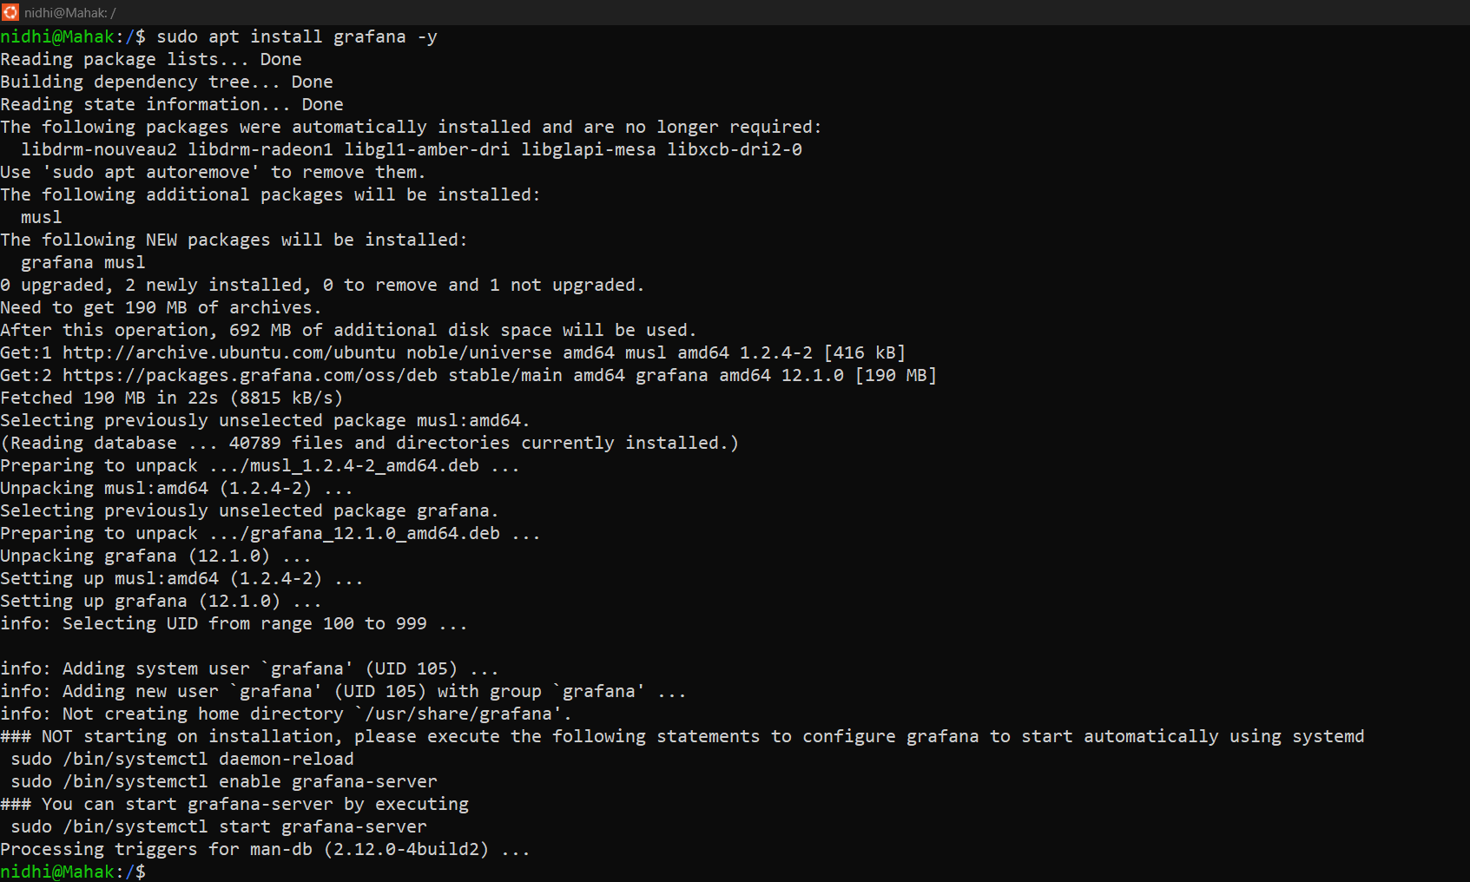

- Start the Grafana service:
  - sudo systemctl start grafana-server

- Enable it to start on system boot:
  - sudo systemctl enable grafana-server

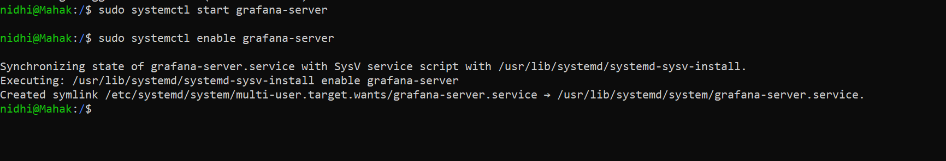

- Now open this in your browser:
http://localhost:3000

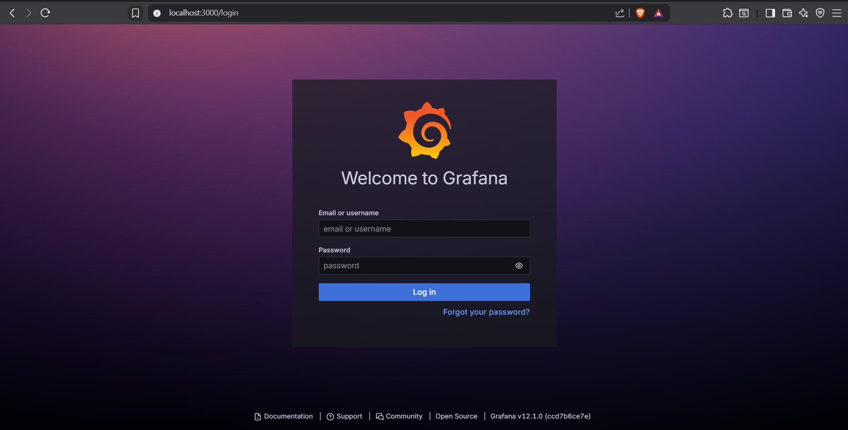

- Login credentials:
- Username: admin
- Password: admin
It will ask you to change the password on first login.

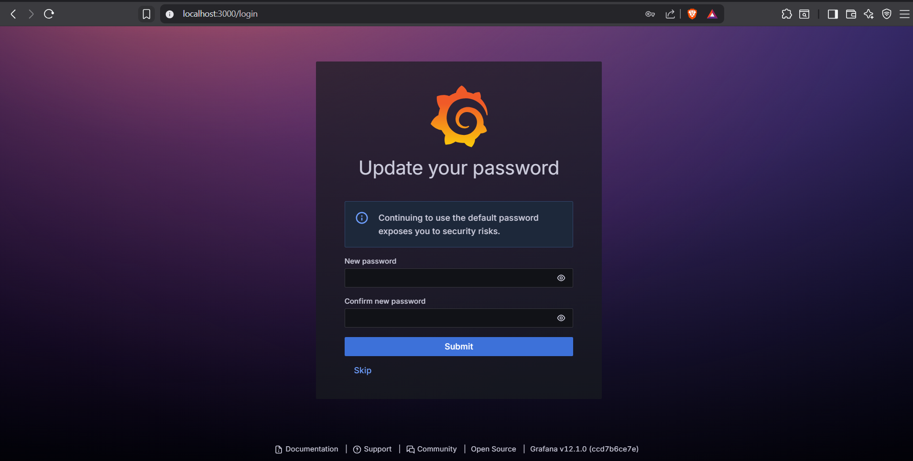

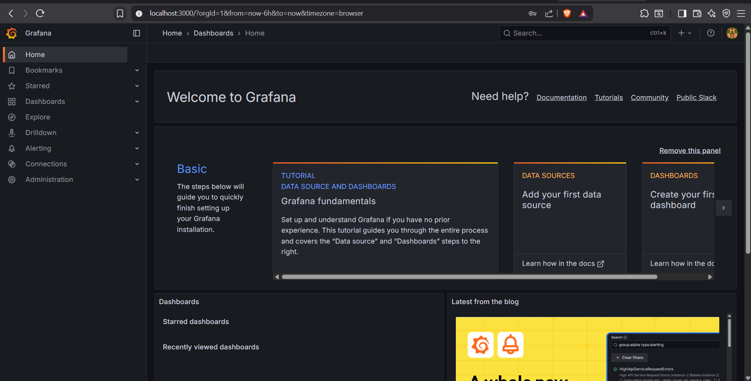

Step 9: Add Prometheus as Data Source in Grafana

- In Grafana UI → Left menu → Connections → Data Sources

- Click Add Data Source

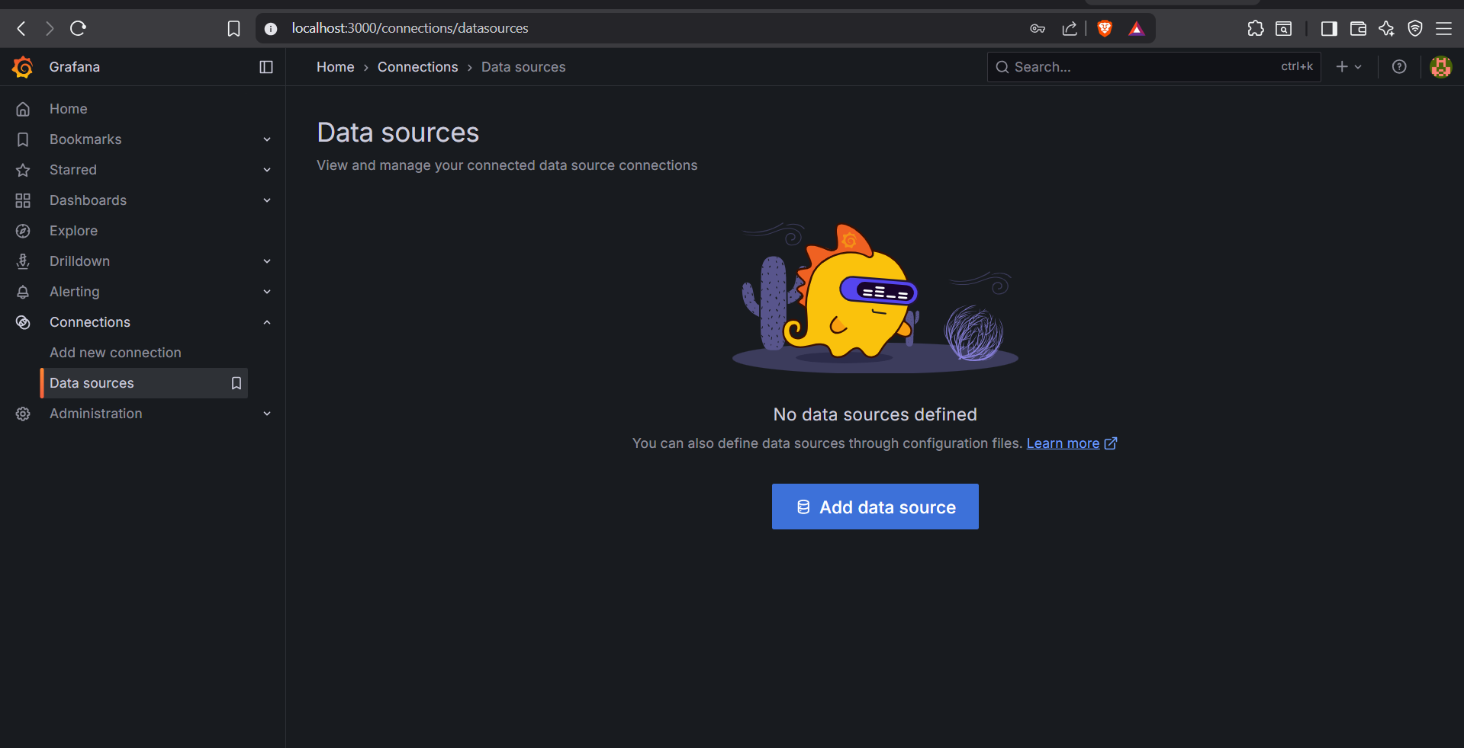

- Choose Prometheus

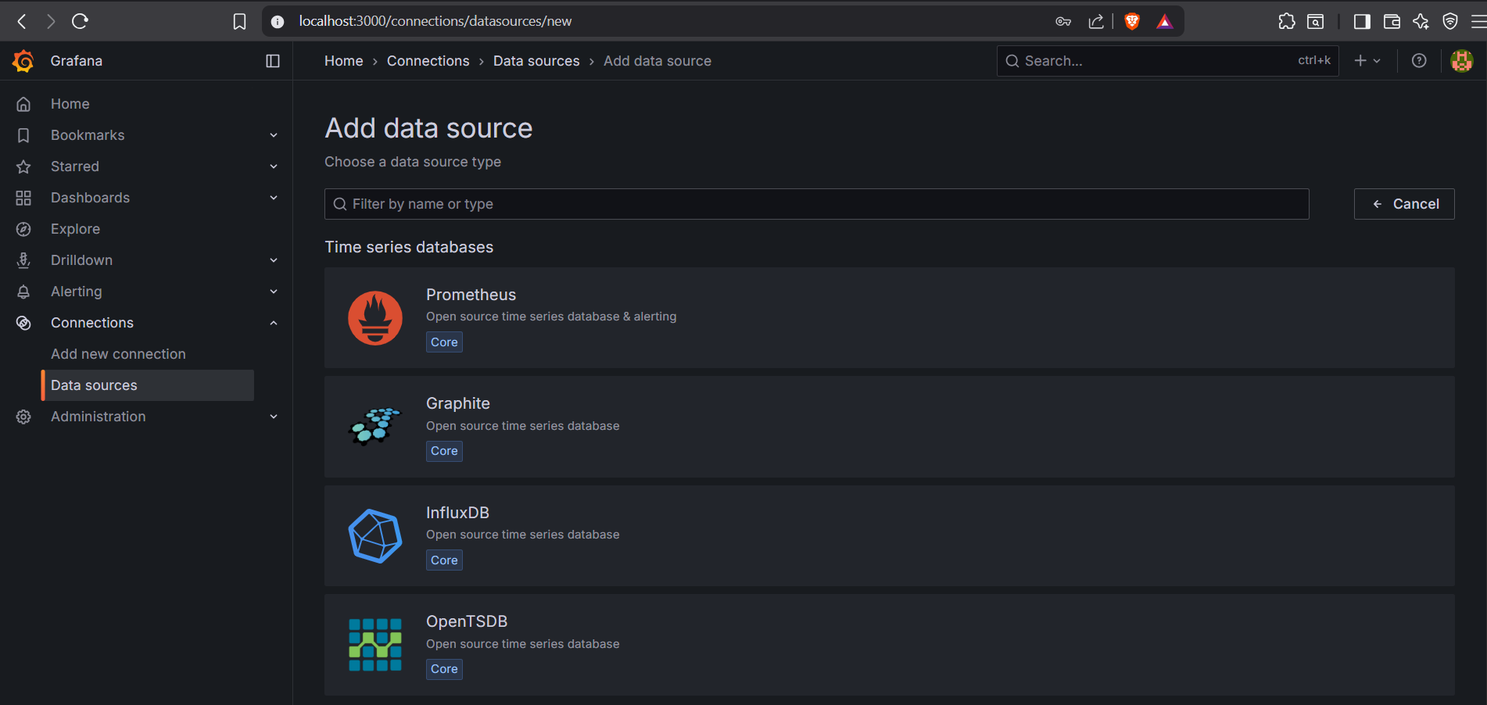

- Enter URL: http://localhost:9090

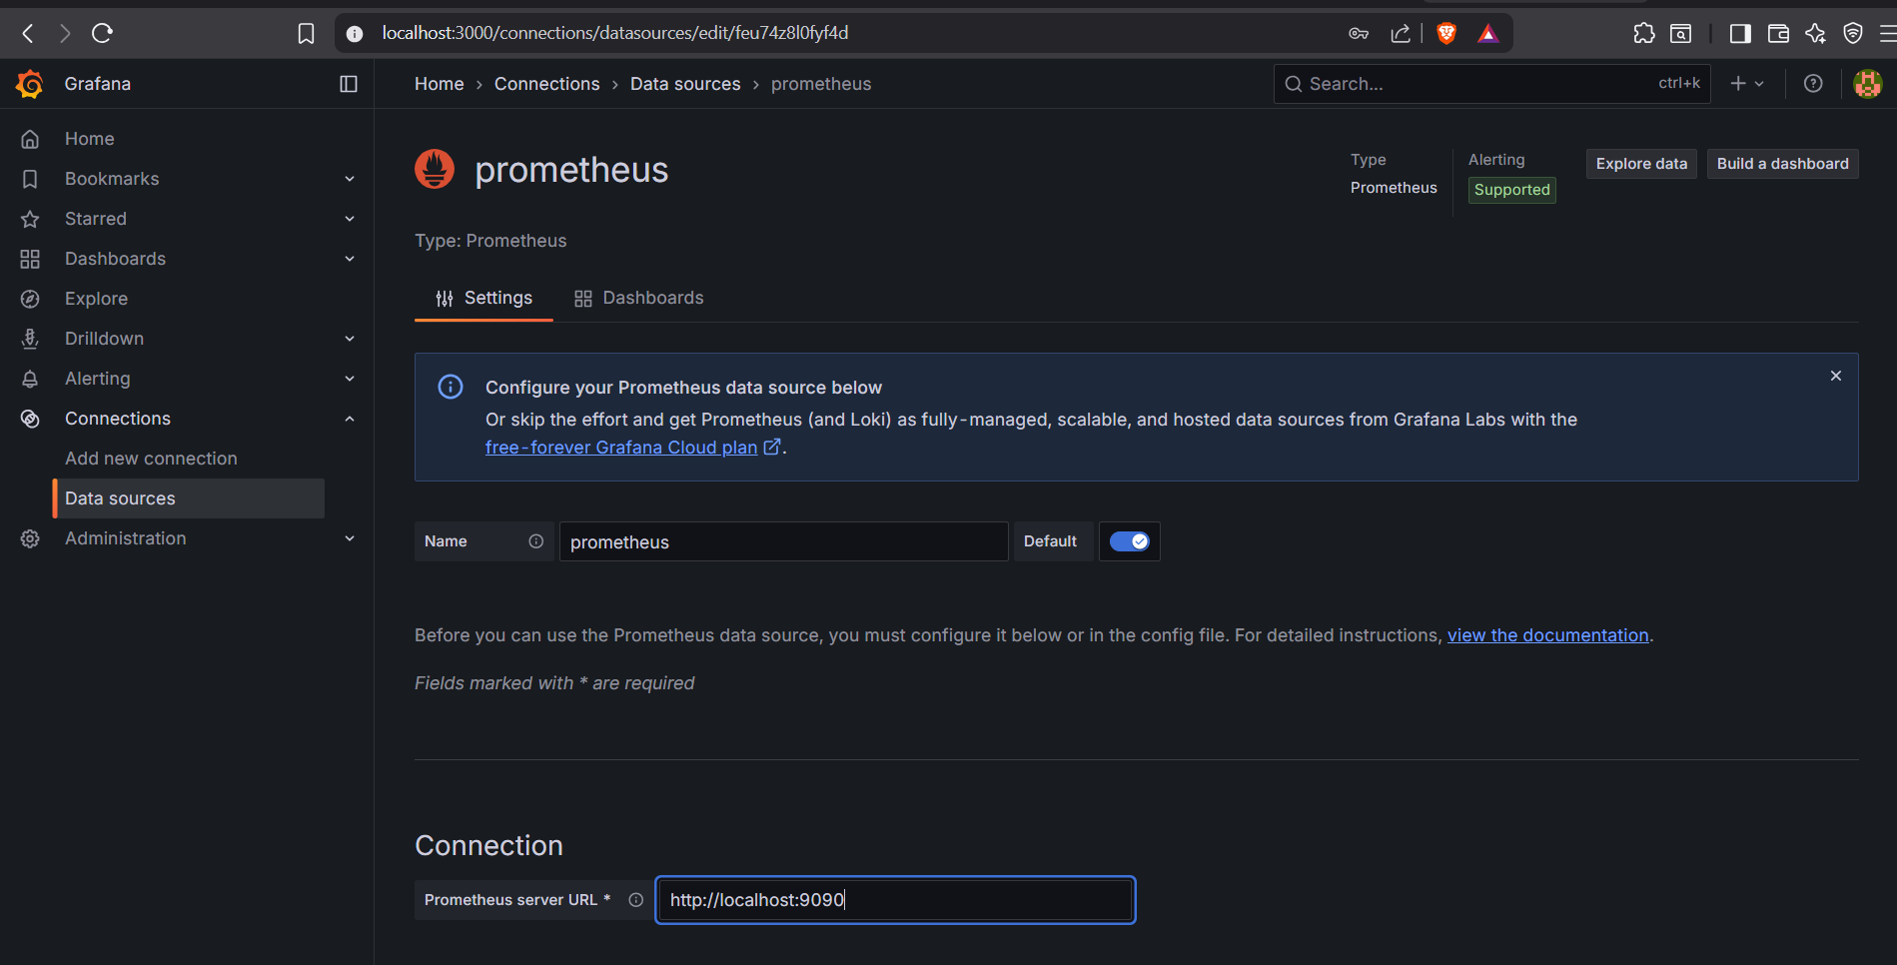

- Click Save & Test



Conclusion

By following this guide, you have successfully:
- Installed and configured Prometheus for metrics collection.
- Set up Node Exporter to gather system-level statistics.
- Installed and started Grafana for creating rich, customizable dashboards.
- Integrated Prometheus with Grafana as a data source.

You now have a complete monitoring setup capable of tracking system performance and visualizing key metrics in real time. This foundation can be expanded to monitor multiple servers, services, and applications, making it a powerful tool for system administrators and DevOps engineers.

